Shreyansh Gupta (12209326)

Roll No. : A09

Ishant Rai (12212546)

Roll No. : B46

Akhilesh Dutt (12206835)

Roll No. : B75

Topic : Sport’s Club Website

Abstract : Motive of our website is to Make a platform where people can easily register to different Sport’s Club through our website.

Logo :



Code:

(In the inserted Zip file)

Website:

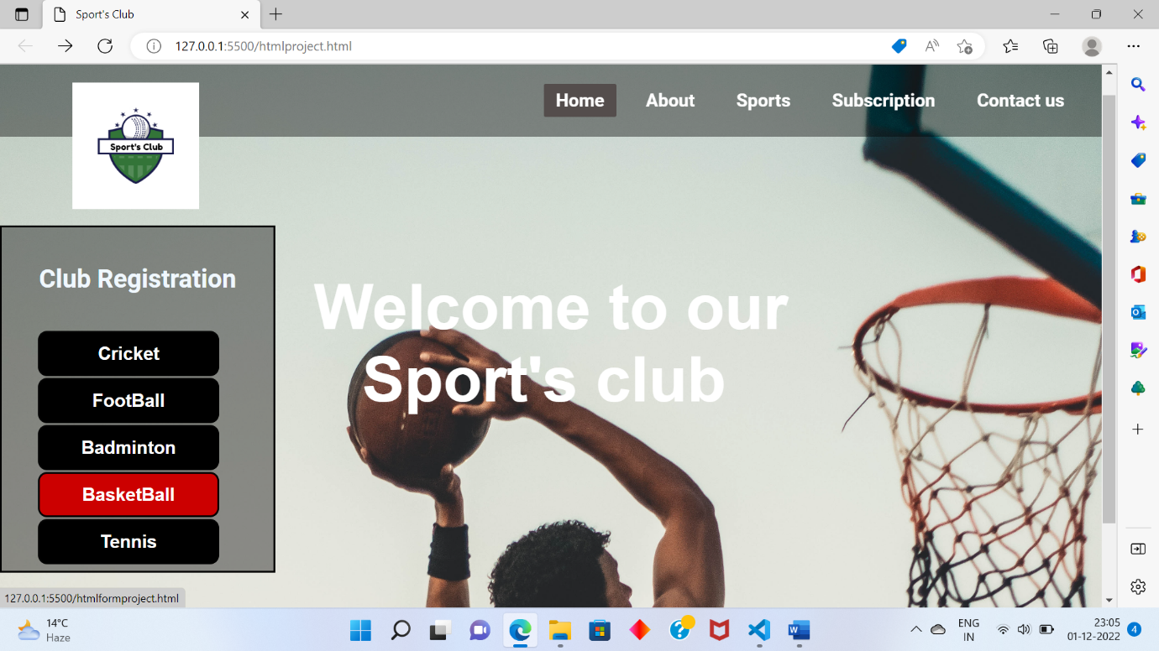

Concept Used:

1.HTML

2.HTML Forms

3.Inline CSS

4.Internal CSS

5.External CSS

Details:

In this project :

“htmlproject” file : where code of front page is written.

”cssproject” file: CSS code of front page.

“htmlformproject” file : Code of Club Registration form.

“cssform” file: CSS code of Club Registration form.

“contact” file: code for contact button